**Noise analysis of Electronic circuits**

Circuit 1:



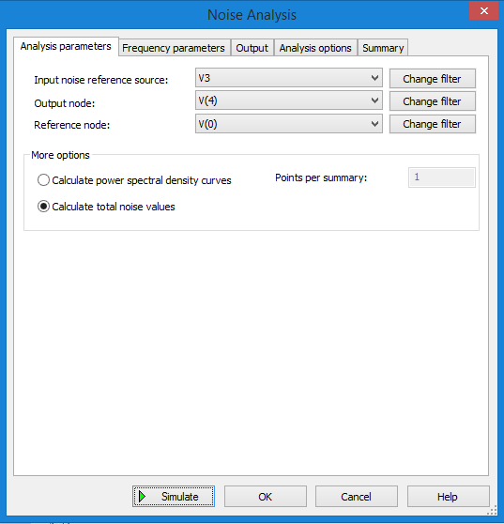

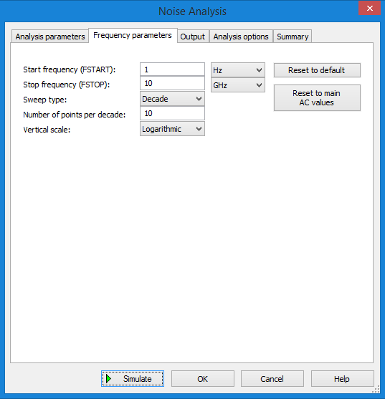

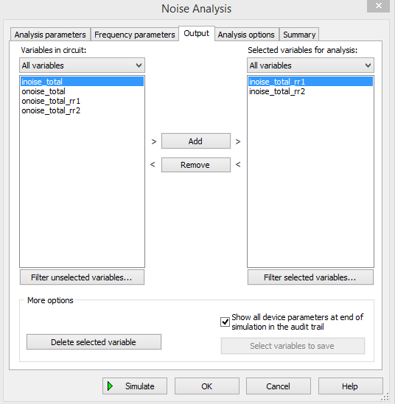

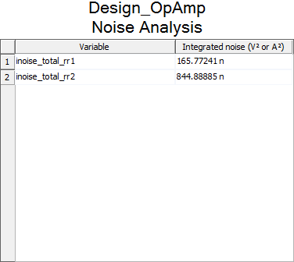

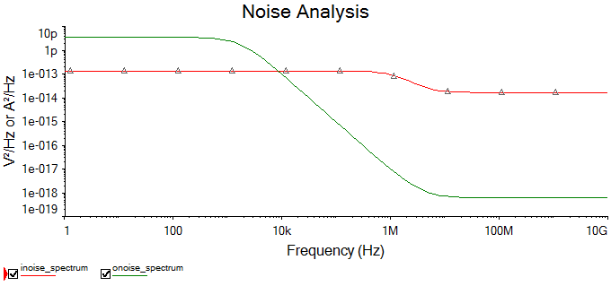

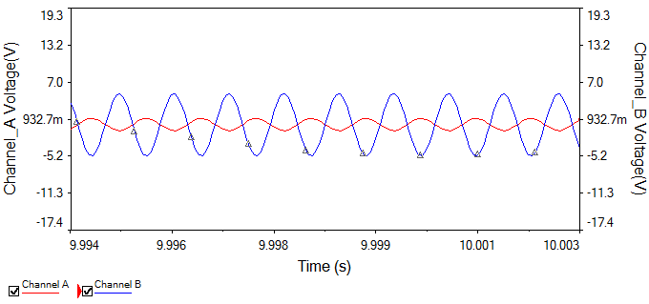

Circuit 2:



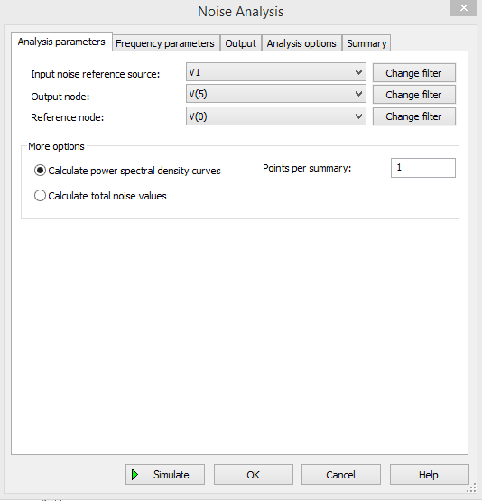

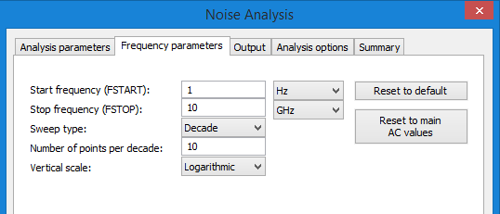

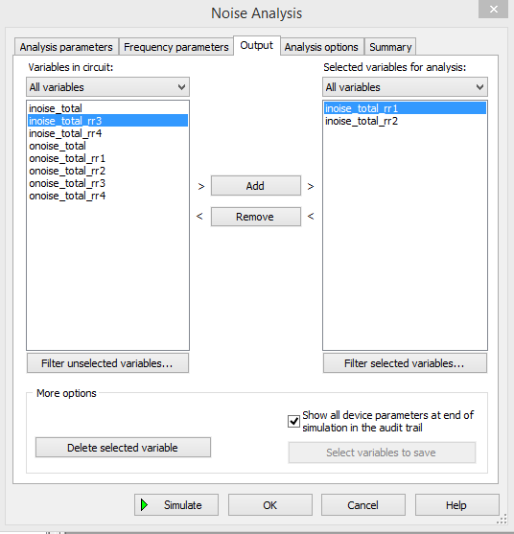

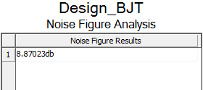

**Discussion Questions**

1. Logarithmic decibel if a unit of measurement used to express the ratio of powers on a logarithmic scale. This is often used for measurements of large range.

Signal strength is measured in dBm i.e., decibels of radio power per milliwatt.

1. Types of noises:
   1. Thermal noise (Johnson noise/white noise): It is temperature dependent noise and caused by thermal interaction between free electrons and vibrating ions in a conductor.
   2. Shot noise: It is caused due to discrete particle nature of current carriers in all form of semiconductors.
   3. Flicker noise (Excess noise/ pink noise): It is generated by BJTs and FETs and occurs in frequency below 1 KHz. It is inversely proportional to frequency and directly proportional to temperature and DC current levels.
2. By increasing gain of the amplifier, noise is also increased.
3. Noise voltage decreases as frequency increases due to **Flicker noise / pink noise.** This occurs at low frequency below 1 KHz



1. Flicker noise is inversely proportional to frequency (noise is max at lower frequency) and directly proportional to temperature (noise increases with temperature). And thermal noise is directly proportional to temperature.
2. **Noise analysis** calculates the noise produced at any particular circuit node as a result of noise-generating elements such as resistors.

**The noise figure** is used to specify exactly how noisy a device is. For a transistor, noise figure is simply a measure of how much noise the transistor adds to the signal during the amplification process.